
LESSON NOTE | DETAILED EXPLANATORY NOTES
ECOLOGY & EVOLUTION
NATURAL SELECTION & EVIDENCE FOR EVOLUTION

GRADE 12 - BIOLOGY
■ ■ ■

The Engine of Evolution
Natural selection is the main process that drives evolution. It is the idea, put forward by Charles Darwin, that individuals best suited to their environment are more likely to survive and reproduce, passing on their helpful features. Over many generations, this gradually changes a population - sometimes so much that new species form. Because we cannot watch most evolution happen, scientists rely on many independent lines of evidence to show that it has occurred and is still occurring.
This lesson breaks natural selection into its clear steps, shows it happening in a real example (the peppered moth), and reviews the main evidence for evolution - from fossils to DNA. It builds on the Darwin vs Lamarck lesson and is a central topic in the Ecology & Evolution strand.
Why This Matters
- Natural selection explains how organisms become adapted.
- It is supported by many independent lines of evidence.
- It explains real problems like antibiotic resistance.
- It is a unifying idea across all of biology.
Natural Selection / Evidence for Evolution
Key Learning Outcomes
By the end of this lesson, students should be able to:
- List and explain the steps of natural selection.
- Explain 'survival of the fittest' correctly.
- Use the peppered moth to show natural selection in action.
- Describe the main types of evidence for evolution.
- Relate natural selection to real-world examples such as antibiotic resistance.
The Steps of Natural Selection
Natural selection can be broken into four clear steps. First, variation: individuals in a population differ from one another, and much of this variation is inherited. Second, competition: more offspring are produced than can survive, so there is a struggle for limited resources such as food, space and mates. Third, selection: individuals with variations that make them better suited to the environment are more likely to survive and reproduce - this is 'survival of the fittest'. Fourth, inheritance: the survivors pass on their helpful features to their offspring. Repeated over many generations, this makes the population better adapted.
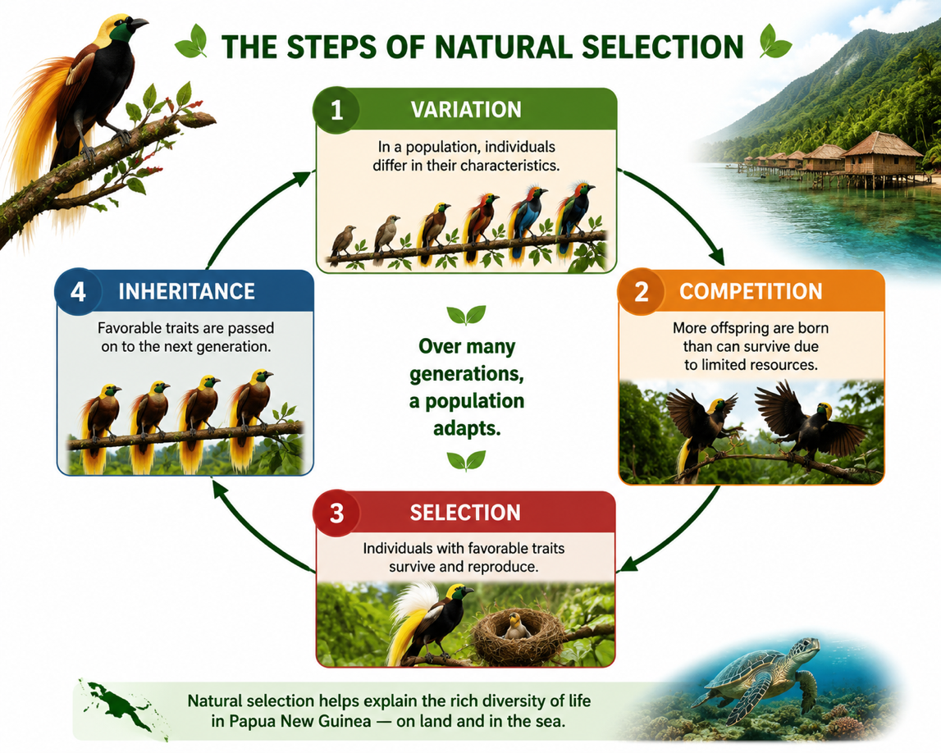
Figure 1: The four steps of natural selection - variation, competition, selection and inheritance.
Terminologies and Concepts
Useful terms for this topic:
- Natural selection: survival and reproduction of the best-suited individuals.
- Variation: inherited differences between individuals.
- Fitness: an organism's ability to survive and reproduce.
- Survival of the fittest: the fittest (best-suited) leave the most offspring.
- Adaptation: an inherited feature that improves survival.
- Homologous structures: similar body parts inherited from a common ancestor.
- Fossil: the preserved remains or traces of a once-living organism.
'Survival of the Fittest' - A Common Misunderstanding
The phrase 'survival of the fittest' is often misunderstood. Here, 'fittest' does not mean strongest or fastest - it means best suited to the particular environment. A well-camouflaged moth, a plant that survives drought, or a bacterium resistant to a drug is 'fit' in this sense. Fitness is also measured by reproduction: the fittest individuals are those that leave the most surviving offspring. Natural selection has no plan or goal - it simply favors whatever variations happen to work best in the current environment.
Natural Selection in Action - The Peppered Moth
The peppered moth in Britain is a famous real example. Before industrialization, most moths were light-colored, camouflaged against pale, lichen-covered tree bark; dark moths were easily seen by birds and eaten. When industrial pollution blackened the tree bark, the situation reversed: now the dark moths were camouflaged and survived, while the light moths were seen and eaten. Over a few decades, dark moths became the most common form in polluted areas. When pollution was later reduced, light moths increased again. This shows natural selection changing a population in response to the environment -and fast enough to observe.
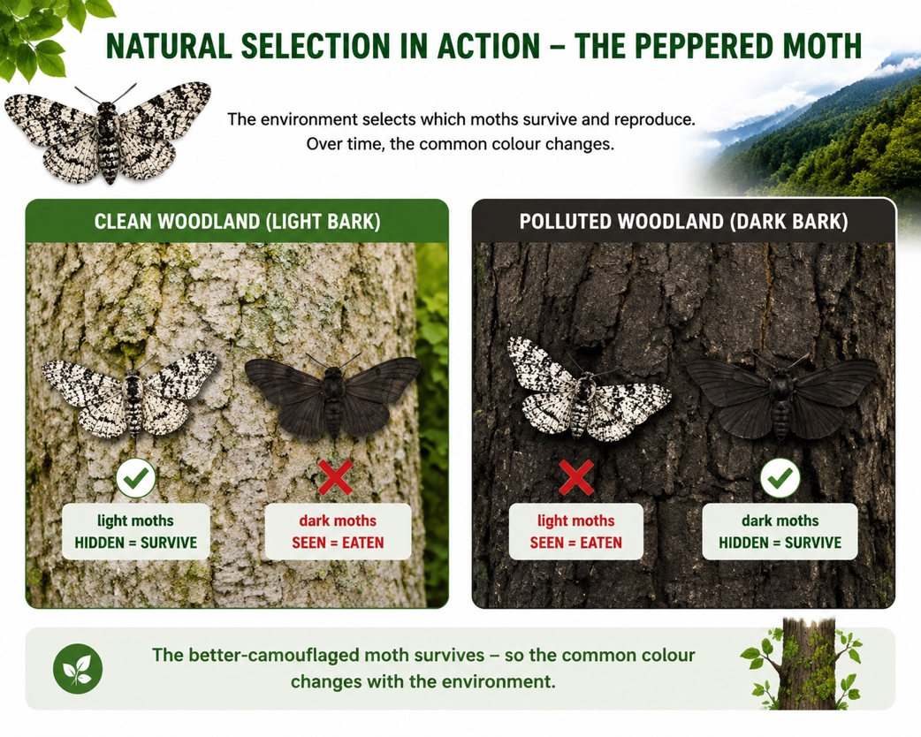
Figure 2: The peppered moth - the better-camouflaged color survives, so the common form changes with the environment.
Evidence for Evolution
Evolution is supported by many independent kinds of evidence. Fossils show that life forms have changed over time and reveal extinct 'in-between' species. Comparative anatomy shows homologous structures - such as the similar bone patterns in a human arm, a whale flipper and a bat wing - pointing to a common ancestor. Embryology shows that related animals have similar early development. Molecular evidence - comparing DNA and proteins - shows that species sharing more genes are more closely related. And direct observation (such as the peppered moth and antibiotic resistance) shows selection happening now. Because these separate lines of evidence all agree, evolution is one of the best-supported ideas in science.
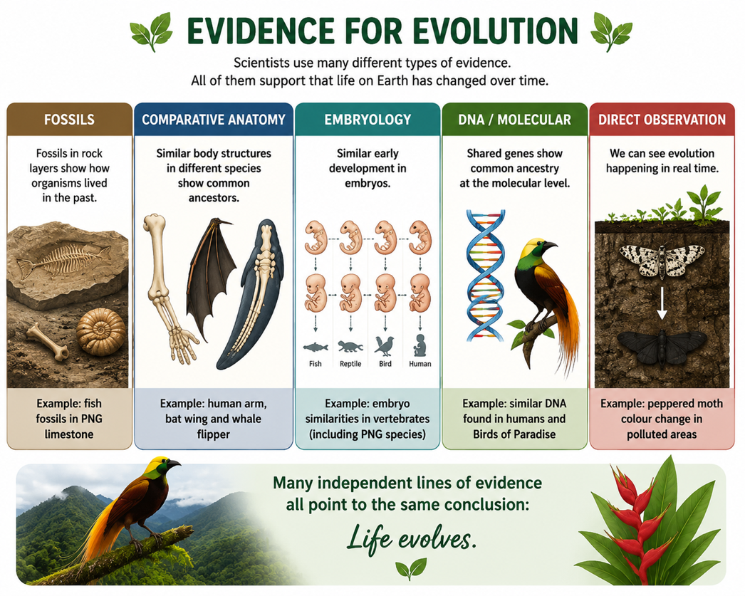
Figure 3: The main lines of evidence for evolution, which all point to the same conclusion.
Why This Matters
- Medicine - natural selection explains antibiotic and pesticide resistance.
- Agriculture - selective breeding uses the same principle deliberately.
- Conservation - it helps predict how species respond to change.
- Understanding life - it unifies all of biology under one idea.
PNG Context Example
Natural selection is at work all around Papua New Guinea. The evolution of malaria parasites and mosquitoes that resist drugs and insecticides is a serious, ongoing example - the resistant individuals survive treatment and pass on their resistance, so treatments must keep changing. PNG's extraordinary biodiversity - thousands of species of insects, birds, frogs and plants, many found nowhere else - is itself powerful evidence of evolution, shaped by natural selection in the country's many isolated habitats. Understanding natural selection helps PNG manage health, agriculture and conservation more effectively.
References & Related Documents
Source Documents
- Biology Standards-Based Syllabus, Grades 11 & 12 (PNG SBC 2020) - Strand: Ecology & Evolution; explain natural selection and evaluate the evidence for evolution.
- STEM Biology Syllabus - Grade 12. Thema: Evolution; Module: Natural Selection and Evidence for Evolution. Department of Education, PNG.
Further Reading & References
- OpenStax Biology - Evidence of Evolution; Mechanisms of Natural Selection. https://openstax.org/books/biology
- Khan Academy - Natural selection and the evidence for evolution. https://www.khanacademy.org/science/biology/her

